**Training Report Day-2**

**7 June 2024**

# ****LISTS IN PYTHON****

Lists are used to store multiple items in a single variable.

Lists are one of 4 built-in data types in Python used to store collections of data, the other 3 are Tuple, Set, and Dictionary, all with different qualities and usage.

Lists are created using square brackets:

#Example

#Create a List:

FRUITS = ["apple", "banana", "cherry", 24, 78.90, True, ["ram", "sham"]]

print(FRUITS)

**Characteristics of list:**

Ordered

Mutable

Heterogeneous

Nestable

Sliceable

#Example

#Lists allow duplicate values:

my_list = ["apple", "banana", "cherry", "apple", "cherry"]

print(my_list)

#Example

#Print the number of items in the list:

UNI = ["CTU", "KTU", "DTU"]

print(len(UNI))

#Example

#Using the list() constructor to make a List:

thislist = list(("apple", "banana", "cherry")) # note the double round-brackets

print(thislist)

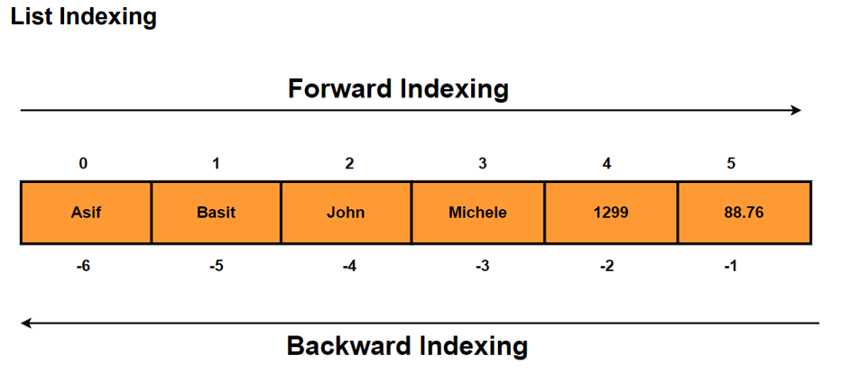

**List methods:**

#LIST METHODS

#APPEND: Used to new elements to the end of an existing list.

#syntax = list_name.append("item")

UNI = ["CTU", "KTU", "DTU"]

UNI.append("CU")

print(UNI)

#appending another list at the end of one list

# we can also append another list in an already existing list in order to make nested lists.

#syntax = list1_name.append(list2_name)

UNI = ["CTU", "KTU", "DTU"]

Courses = ["BCA", "MCA"]

UNI.append(Courses)

print(UNI)

#clear() method: It removes all the elements from the list, meaning makes the list empty.

#syntax = list_name.clear()

UNI = ["CTU", "KTU", "DTU"]

UNI.clear()

print(UNI)

#copy() method: It creates another copy of existing list.

UNI = ["CTU", "KTU", "DTU"]

print( UNI.copy())

colleges = UNI.copy()

print(colleges)

#count(): it counts the occurrence of particular element in a list

#syntax = list_name.count("element")

UNI = ["CTU", "KTU", "DTU", "CTU"]

UNI.count("CTU")

#extend() method: It is used to concatenate 2 existing lists().

UNI = ["CTU", "KTU", "DTU", "CTU"]

UNI2 = ["CU", "PU"]

UNI2.extend(UNI)

print(UNI2)

#remove() : It is also used to remove an element from an existing list like pop() method. But the difference is that it takes element itself as arguement.

FUR = ["TABLE", "CHAIR", "STOOL", "BED"]

FUR.remove("CHAIR")

FUR

#reverse method

FUR = ["TABLE", "CHAIR", "STOOL", "BED"]

FUR.reverse()

FUR

**List slicing:**

List slicing in Python allows you to extract a portion of a list by specifying a range of indices**.**

**Syntax:**

list[start:stop:step]

* **start**: The index where the slice begins (inclusive). If omitted, it defaults to the beginning of the list.
* **stop**: The index where the slice ends (exclusive). If omitted, it defaults to the end of the list.
* **step**: The step size, which determines how many items to skip between indices. If omitted, it defaults to 1.

#example 1

numbers = [1, 2, 3, 4, 5, 6, 7, 8, 9]

# Extracting a slice from index 2 to 5 (exclusive)

slice1 = numbers[2:6]

print(slice1)

#Example 2: Omitting start and stop

# Omitting start, defaults to the beginning of the list

slice2 = numbers[:4]

print(slice2)

# Omitting stop, defaults to the end of the list

slice3 = numbers[5:]

print(slice3)

#Example 3: Using a Negative Index

# Negative index, counts from the end of the list

slice4 = numbers[-5:]

print(slice4)

slice5 = numbers[:-3]

print(slice5)

#Example 4: Step Parameter

# Using step to get every second item

slice6 = numbers[::2]

print(slice6)

# Using step to get every third item

slice7 = numbers[1::3]

print(slice7)